Khoa Tran

EE 271

August 5, 2020

Lab 5 Milestone

**Task #1**

Commented Code for 3-bit counter:

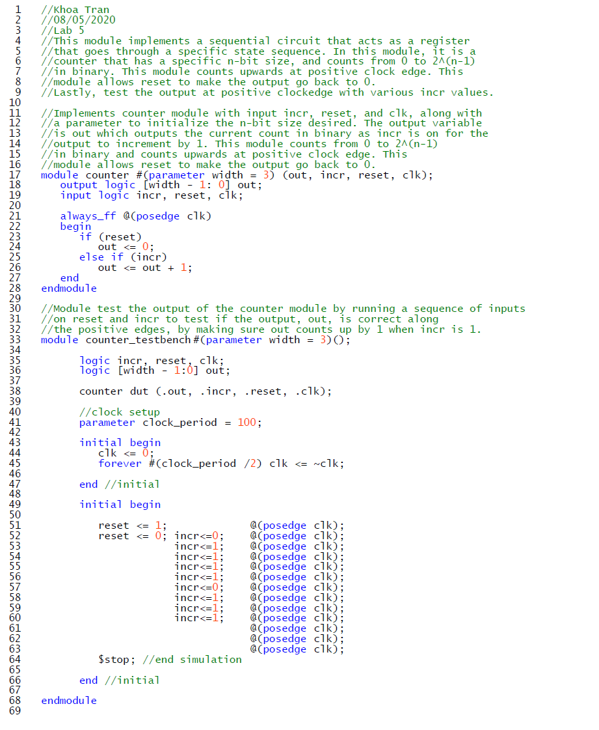

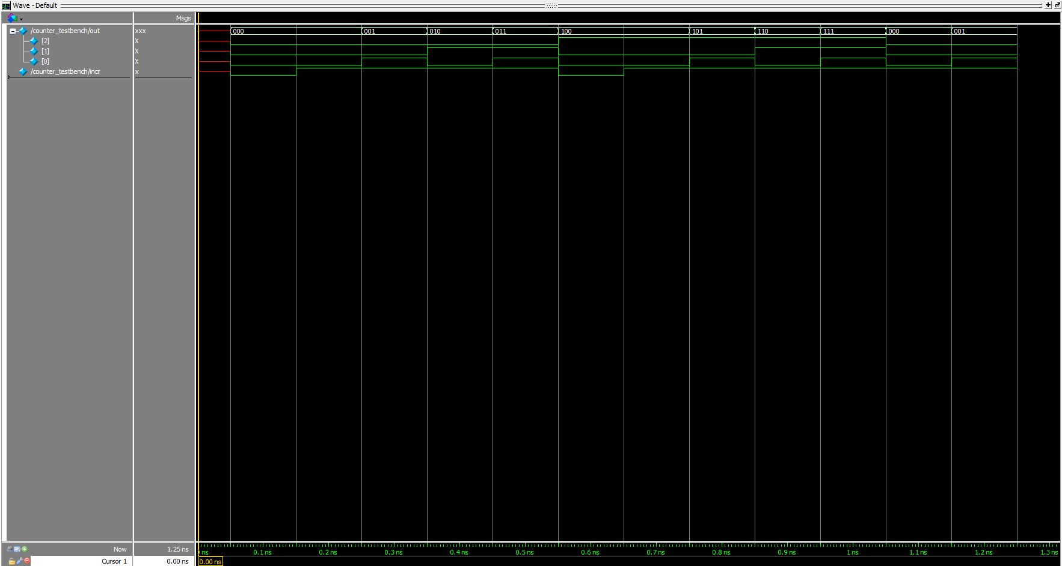Modelsim for 3-bit counter:

**Task #2:**

State diagram for 3 and 4-bit LFSR:

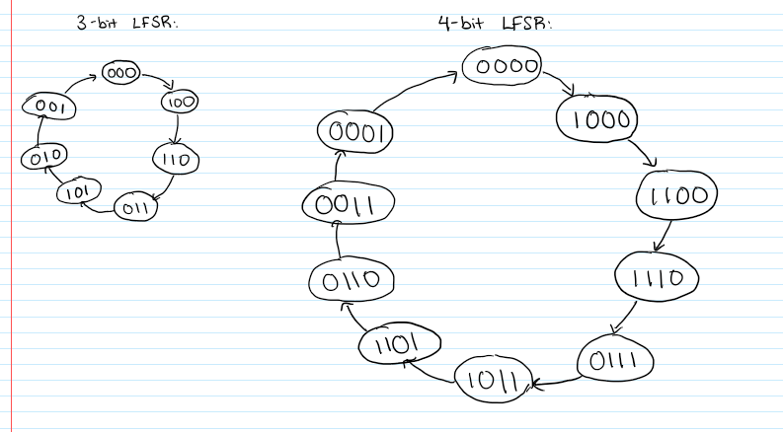

**Task #3:**

Commented code for 10-bit LFSR:

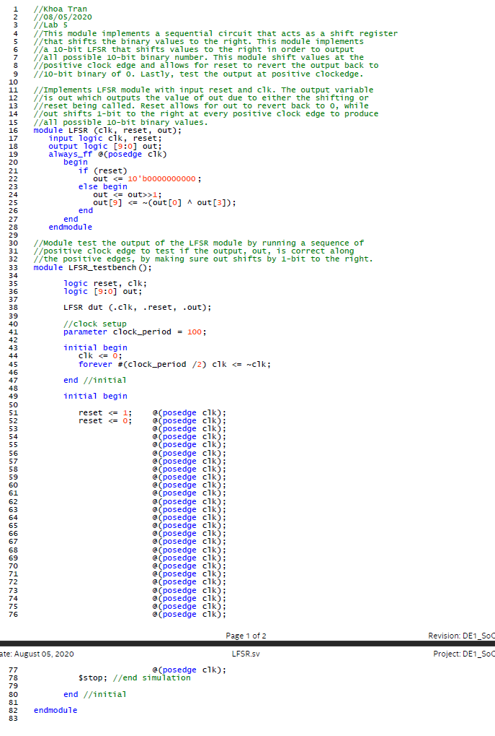

Modelsim for 10-bit LFSR:

